Windows Application Automation

Contents

A. Installation 1

1. WhiteLibrary 1

2. SikuliLibrary 2

1. AppiumLibrary 2

# Installation

## 2. Windows Application Driver

Windows Application Driver (WinAppDriver) is a service to support Selenium-like UI Test Automation on Windows Applications. This service supports testing Universal Windows Platform (UWP), Windows Forms (WinForms), Windows Presentation Foundation (WPF), and Classic Windows (Win32) apps on Windows 10 PCs. WinAppDriver complies to the JSON Wire Protocol standard and some application management functionalities defined by Appium.

More information should be read from its GitHub: <https://github.com/microsoft/WinAppDriver>

Step 1: Download and install WinAppDriver latest version (ver. 1.1.1 as May 2019). WinAppDriver can be downloaded at: <https://github.com/Microsoft/WinAppDriver/releases>

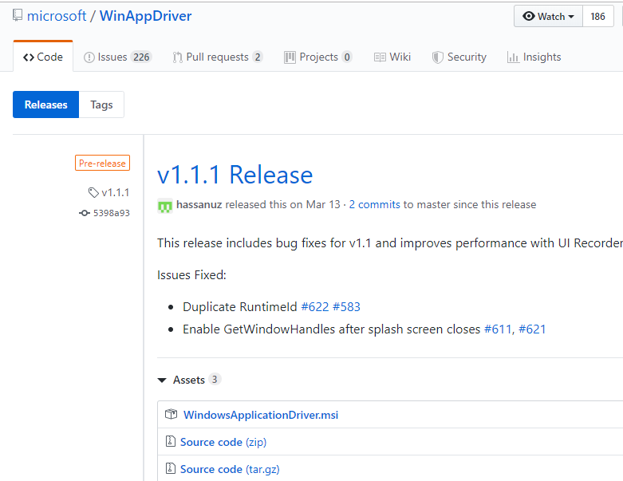

## 2. SikuliLibrary

Step 1: In an existing or new python project, open Terminal and execute following command:

pip install robotframework-SikuliLibrary

Step 2: Verify installed packages in Files > Settings: robotframework (if not) and robotframework-SikuliLibrary.

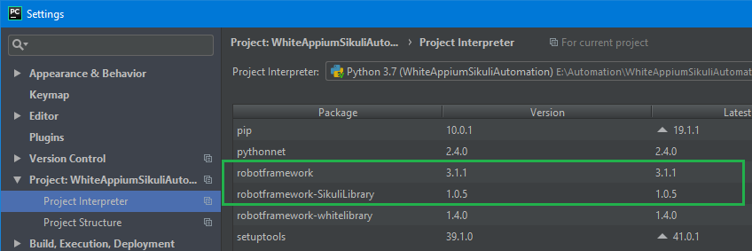

Step 3: Verify SikuliLibrary by composing and running a simple test case as follow:

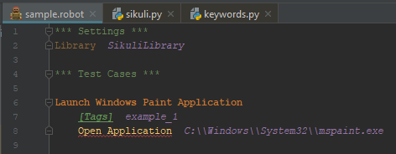

## 3. AppiumLibrary

Step 1: In an existing or new python project, open Terminal and execute following command:

pip install robotframework-appiumlibrary

Step 2: Verify installed packages in Files > Settings: robotframework (if not), kitchen, decorator, urllib3, selenium, six, docutils, Appium-Python-Client and robotframework-appiumlibrary.

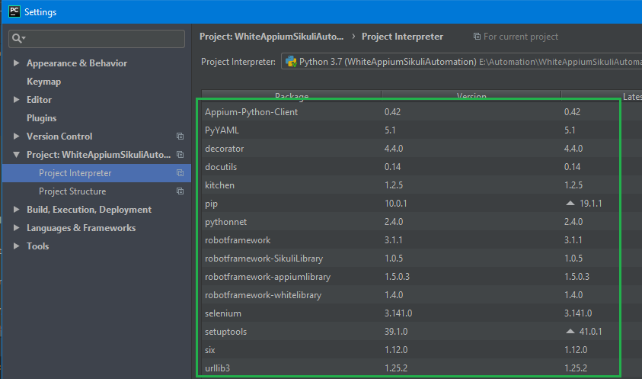

Step 3: Install Appium Desktop application by going to <https://github.com/appium/appium-desktop> and click on **Release** tab to download the latest version of Appium.

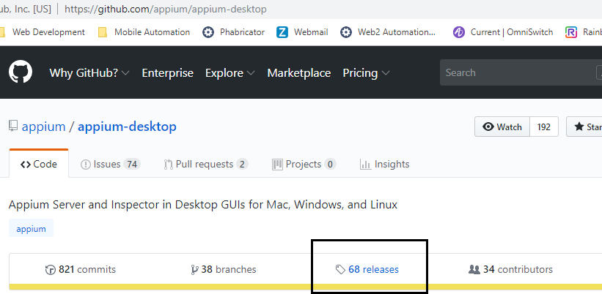

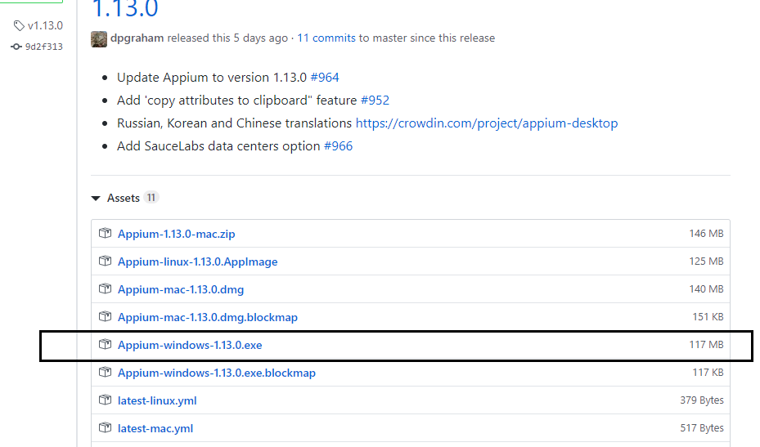

Step 4: Install Windows Application Driver (WinAppDriver) by going to <https://github.com/microsoft/WinAppDriver> and click on **Release** tab to download the latest version of WinAppDriver.

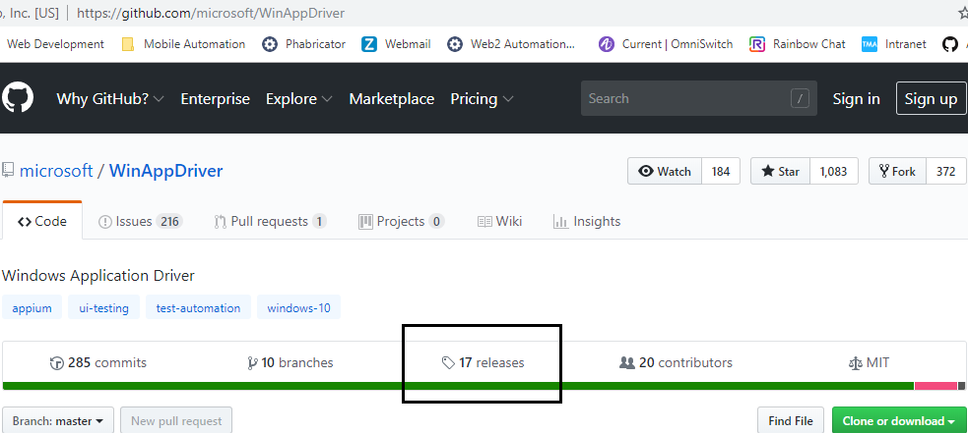

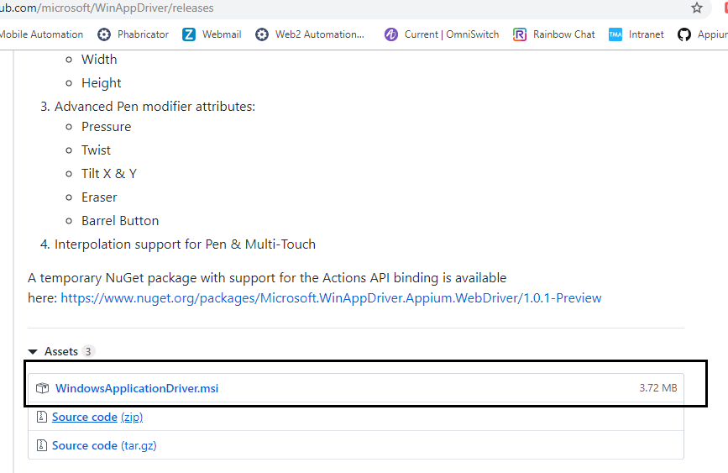

Step 5: Enable Developer mode on Windows by going to Settings:

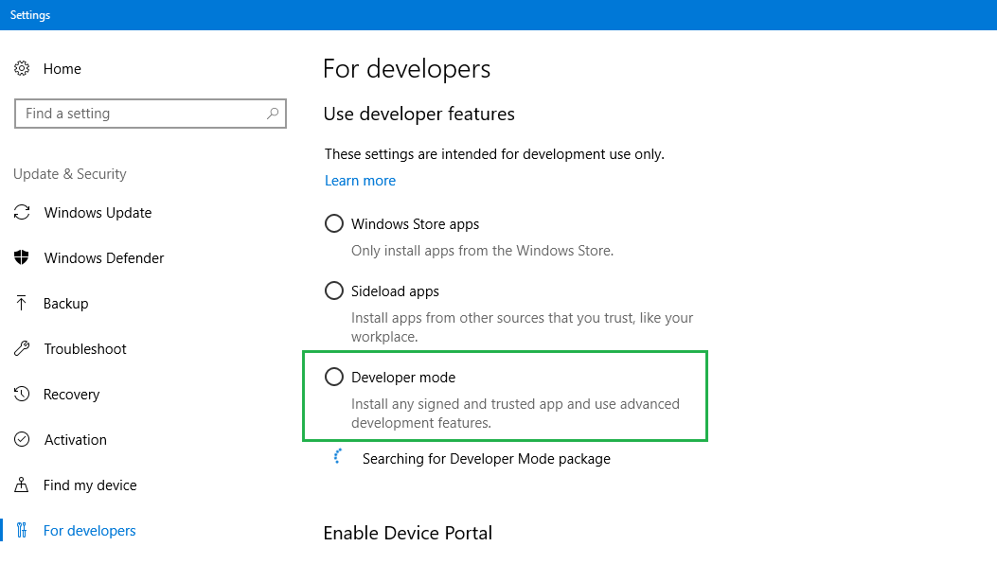

Step 6: Install Appium Desktop & WinAppDriver applications. Run Appium Desktop application and Start Server (default port is 4723).

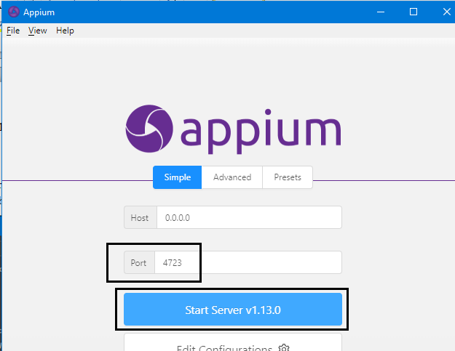

Step 7: Verify AppiumLibrary by composing and running a simple test case as follow:

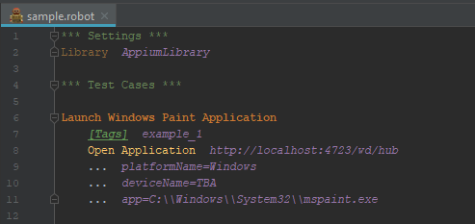

# Customization

## 1. SikuliLibrary